驻达沃总领馆领事证件交费须知

一、申请人可前往任意BDO银行网点交纳领事证件费用。总领馆已与BDO银行达成便利化安排，银行承诺在SM City BDO Annex Branch设立领事证件交费专属窗口，并提供免排队服务。
二、交费基本流程
1、申请人在总领馆申请证件时，如申请已被受理，总领馆工作人员将开具取证单，并向申请人提供BDO银行“现金交易单（Cash Transaction Slip）”（见下图）。如3个工作日内未接到总领馆人员电话通知，请在交易单上填妥以下信息，并携带此单前往任意BDO银行网点交纳费用：
付款人姓名（Payor's Name）：请用英文字母填写证件申请人姓名，护照申请人请填写姓名拼音；
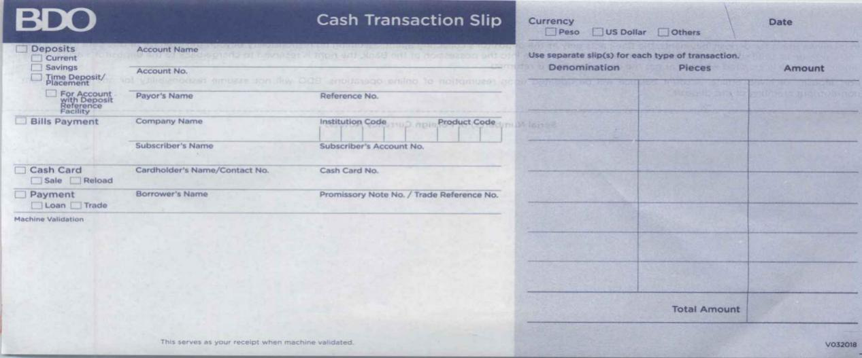参考编号（Reference No.）：请填写8位数字的取证单号码。

取证单号
申请人姓名 （拼音）

2、抵达BDO银行网点后，请持填妥的现金交易单和相应现金往柜台交费。
3、付款后，银行柜员会将现金交易单副本作为付款凭证退还给您。离开柜台前，请认真核对副本信息，特别是确认付款人姓名和参考编号是否正确。如发现错误，请立即通知银行柜员纠正，否则将影响您此后凭交易单副本等领取证件。
三、领取证件
请一并携带取证单和现金交易单副本，往总领馆取证窗口领取证件。

PAYMENT NOTICE
- The applicant may proceed to any BDO branch to pay for the Consular Document Fees. For the convenience of the applicant, the Consulate General has made an arrangement with BDO SM City Annex branch, whereby a specific counter is assigned for the payment of fees and the applicant does not have to take queue.

- Payment Process

- Once the application has been accepted, the staff of the Consulate General will provide a Pick-up form and a BDO Cash Transaction Slip (Please see the picture attached below). The applicant may proceed to pay the fees 3 days after the submission of the application documents, if the applicant does not receive a call from the Consulate. Before proceeding to BDO, kindly accomplish the slip with the following details:

Payor’s Name: (For passport applicants, please fill with Pinyin);
Reference No.: 8-digit Pickup form number
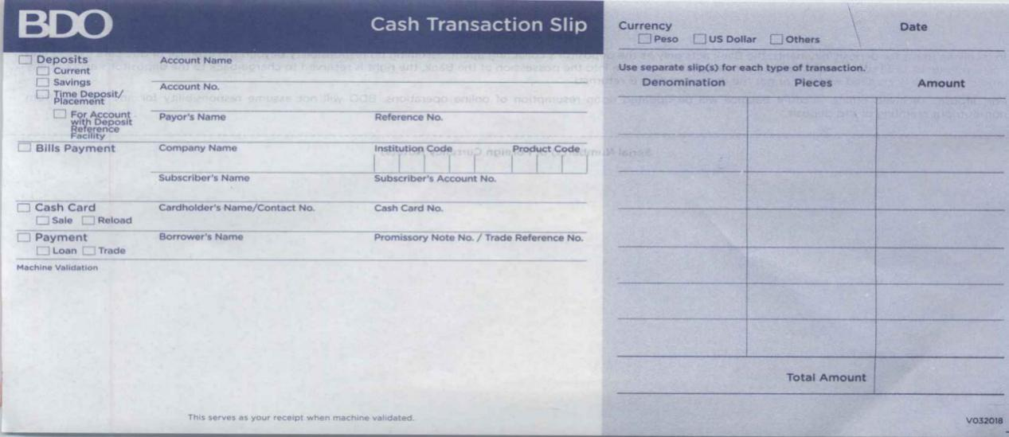

Pick-up form Number
Applicant’s Name

- Present the Cash Transaction Slip to a BDO teller together with your cash payment as indicated.

- After payment has been made, a validated Cash Transaction Slip will be given by the teller. Before leaving the counter, kindly double check and verify if the Payor’s Name and the Reference No. is correct. Immediately call the attention of the bank teller if any error is found. Any errors/mistakes found during the releasing date will affect the release of the Consular Documents applied for.

- Pickup of Consular Documents
Please present both the Pick-up form and the validated Cash Transaction Slip to the releasing counter of the Consulate General.

